HATFD1025

Find the Second Largest Element in an Array Write a program to find the second-largest element in an array of integers without using any sorting algorithms or built-in array functions. Instructions: Traverse the array manually to find both the largest and second-largest elements

**CODING**

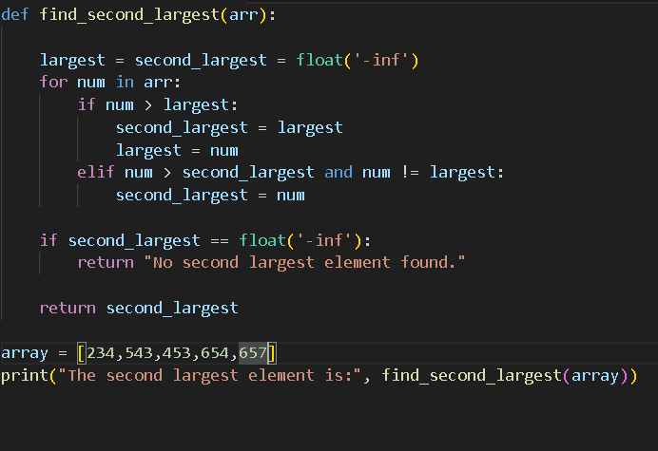

**Example Outputs:**

